

|  |
| --- |
| THE UNIVERSITY OF THE WEST INDIES Semester l **■** Semester II **□** Supplemental/Summer School **□**  **Course Project**  **Name of your Course Project**  **Course Code**: SWEN3001 **Title**: Android App Development I  ID No. __416001313/190904_ Name. ___Ron Alexis_____  Signature ________________________  ID No. ____416001294/190906_____ Name. ___Jason Charles__  Signature ________________________  Date ________________________ Pages _______________________  The following is filled by examiner.  Score ________________________ Examiner signature ________________________  Date _____31st December 2019_____ |

# ACME Bank’s Money Transfer App - Introduction

The system’s main function is to allow for money transfer from one user’s account to another user’s account. This is done by transferring funds through an electronic payment wire transfer, using a messaging network to swiftly and securely transfer money from one account to another’s account. All user information is stored and managed through the bank’s database. Users can also manage their personal accounts through the money transfer application. This application includes several other features such as the ability to manage all user accounts (mortgage, loans and family accounts). The application will also offer customer support and provide offers and specials to users. The system is managed by an administrator, this administrator can cancel transactions and transfers, view user account information (only when required) and transaction information. The user chooses a beneficiary/recipient and sets the amount to be transferred along with important recipient information. Once this is entered the user enters the amount and confirms the transaction. Within seconds the money is sent from the user’s account to the beneficiary/recipient’s account. A notification will be sent to both users stating the amount sent, the amount received, and any transaction fees deducted or charged. Users can also transfer money between accounts with no charge, for example from one user savings account to another savings account. The users also have the luxury of their own personal assistant. In version 1.3 the assistant was named “Inno”, in further updates as can be seen from the images (version 1.9), the name was removed but the bot still functions the same. The application has many post-transfer features such as filtering and searching, of accounts (saving & loan), applying for loan and adding a beneficiary.

# Stakeholders

A stakeholder is any on who has vested interest in the application or system that has been created or is being created. The bank (ACME) is the company that has invested time and resources into the creation of the application, by hiring a team of developers to be able to create a system. They are also invested as the application is built to address a specified business goal, which in turn would allow for the business to make a profit or be able to satisfy customers which would help the growth of the business. The customer is the person who will be using the application which has been developed. This is the customer who believes that the product has solved a specific issue or meet a specified market segment. The interest in the product makes the customer a stakeholder. In the development of an application, balancing of the wants and must of the stakeholder’s shapes and helps to mold the outcome of the system.

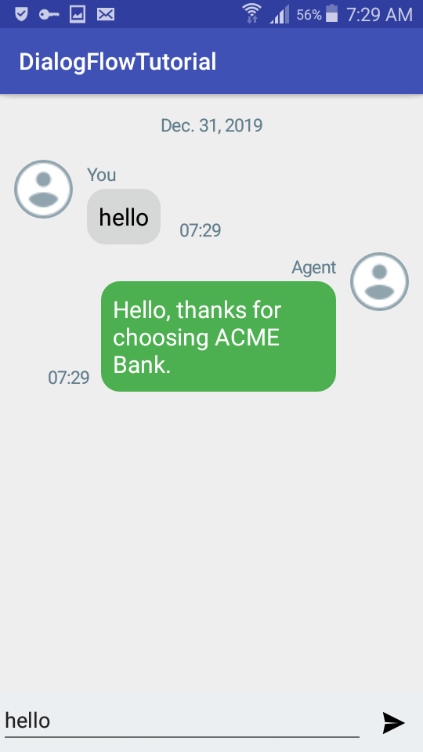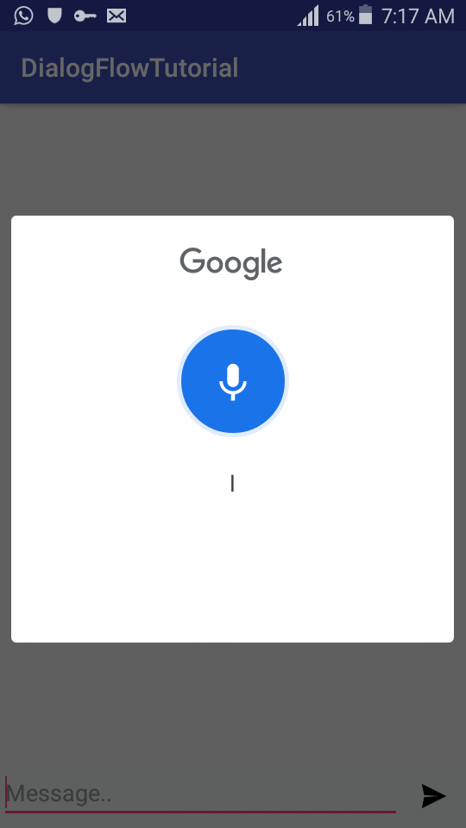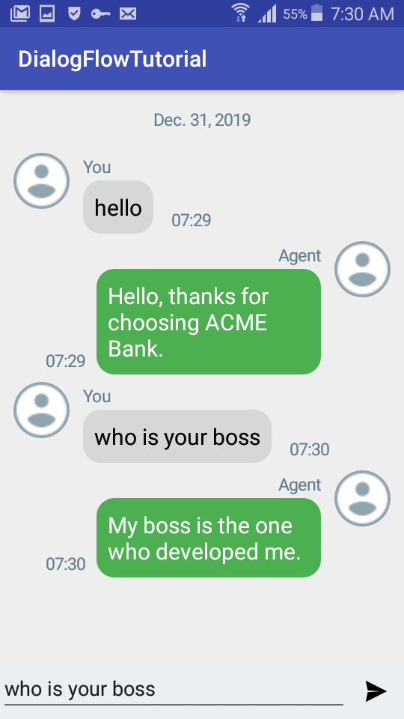

The new application is more efficient. Once the user clicks on the “Assistant” button and waits for a short period of time, the assistant can then accept input to serve the user. This is done using Google’s “Dialogflow”. The application was developed through the help of Mifos’ online tutorials. Many of the in class exercises allowed for specific in app development options such as toasts, spinners, navigation bar, settings and many others.

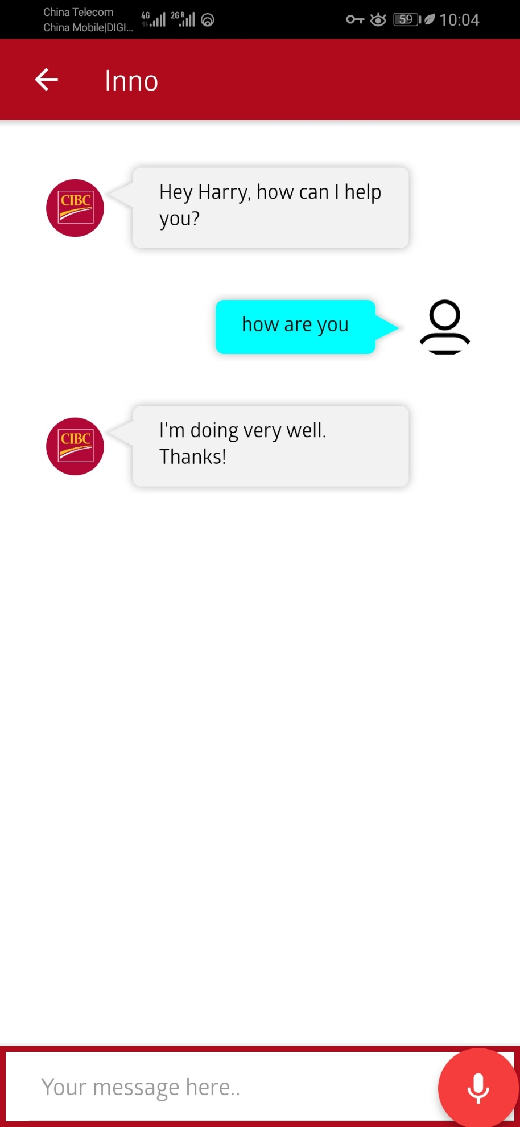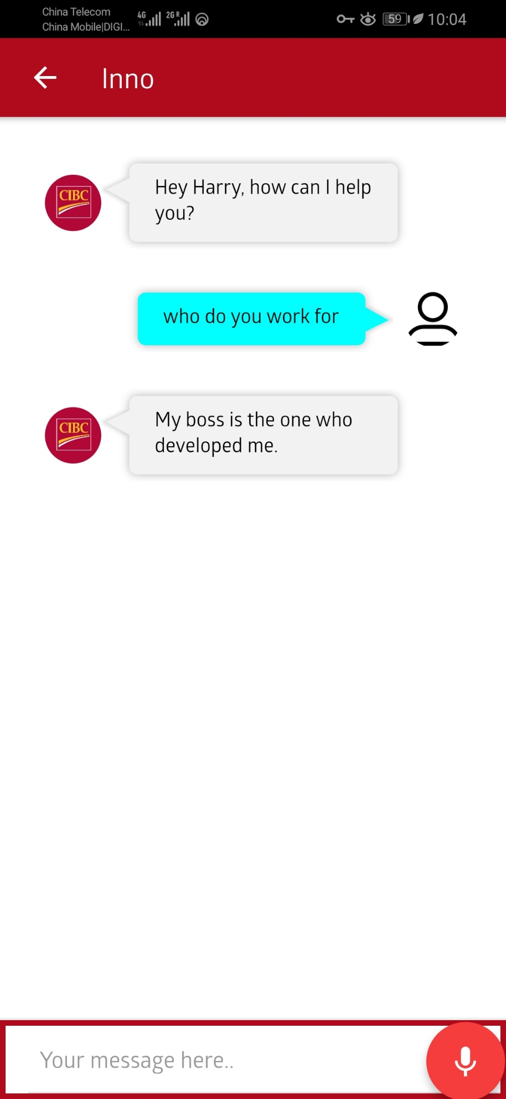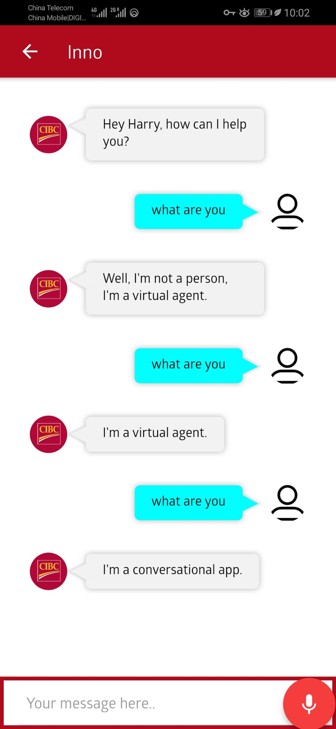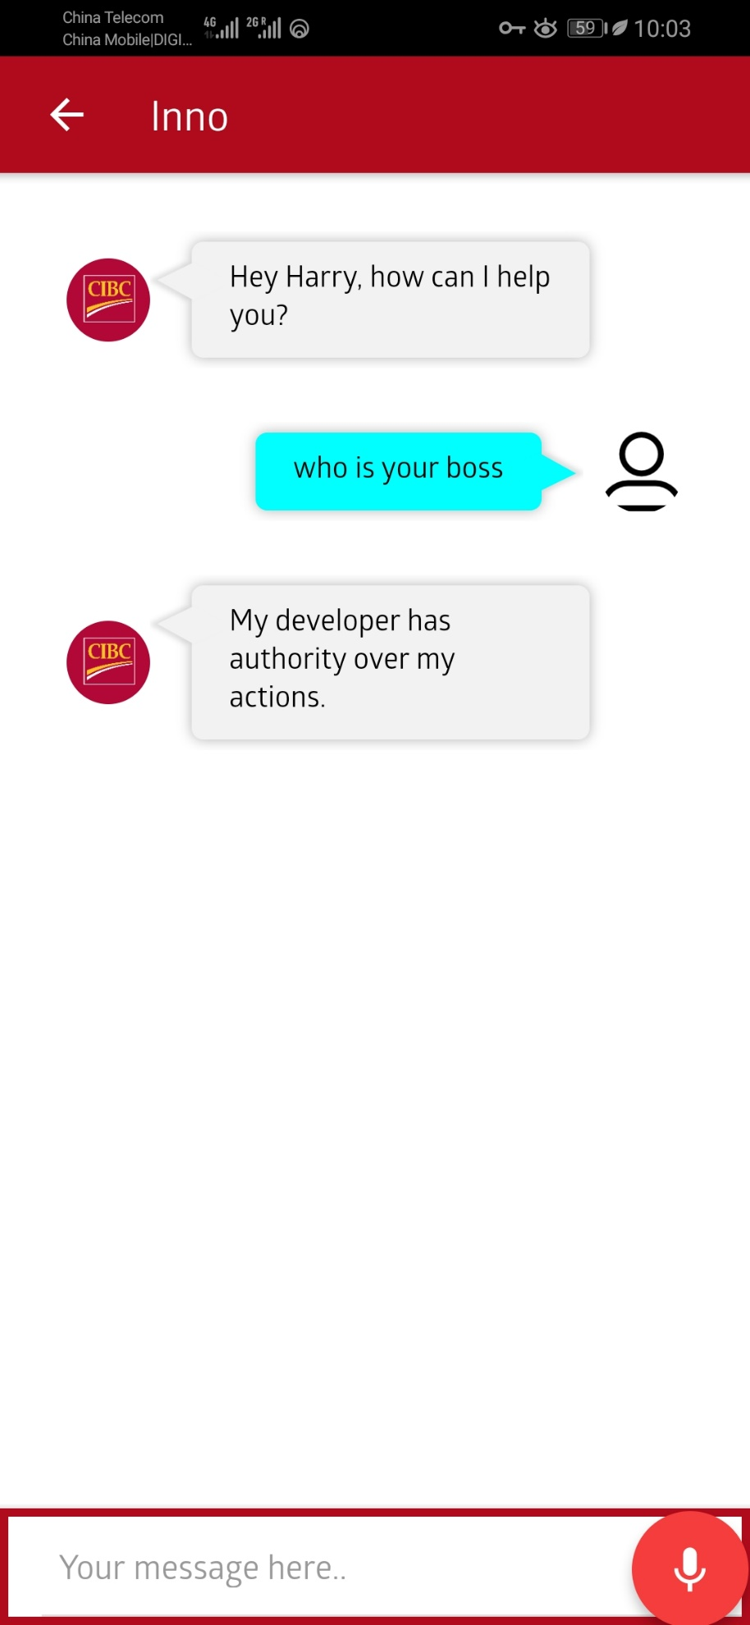

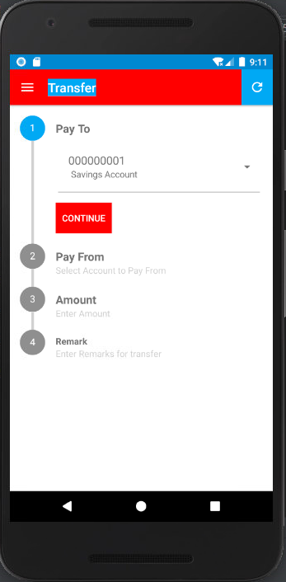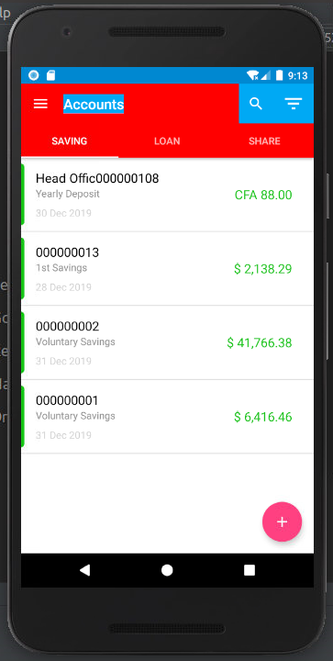

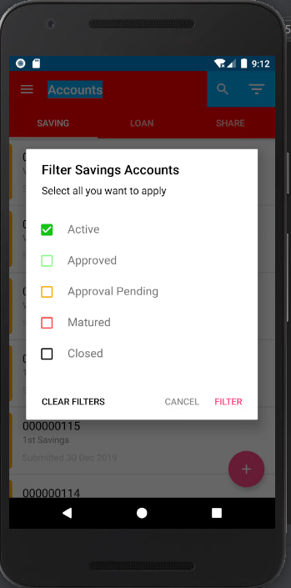

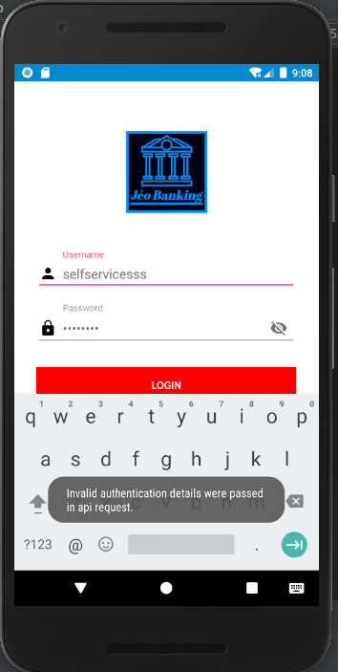

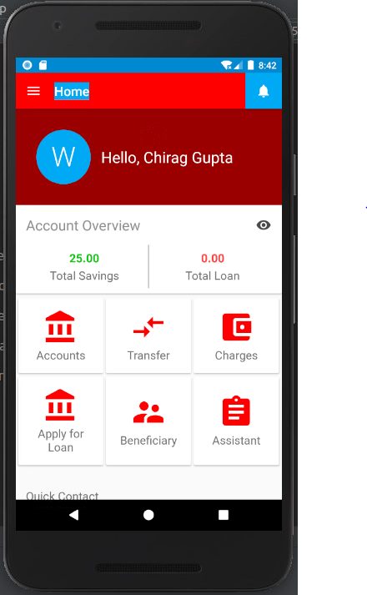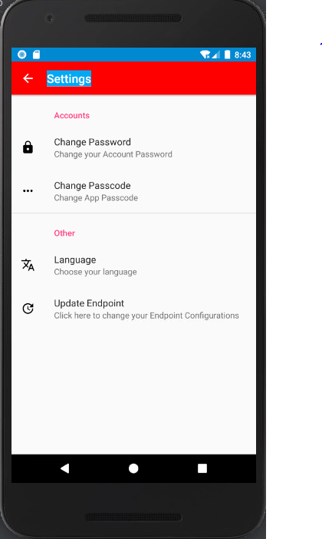

System diagrams and Specifications

## CLASS DIAGRAM

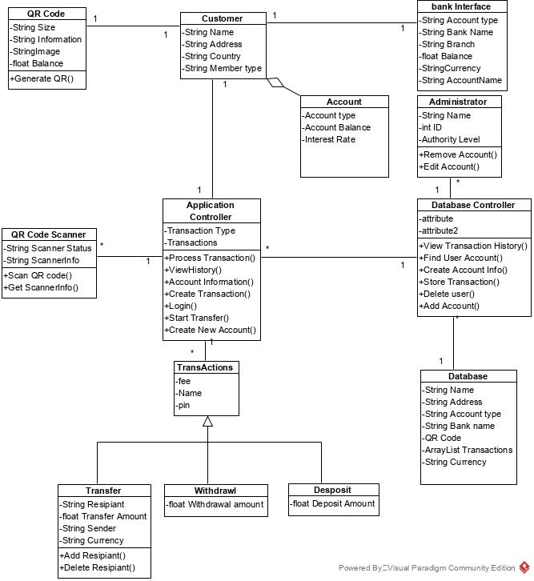

**1.0 Class Diagram**

## CLASS DIAGRAM

The class diagram which is displayed above is the class diagram for the bank application transfer system. This depicts the classes which were created for the application to complete all tasks smoothly and without any impediments.

The system is governed by two controllers which oversee the management and communication of the application, these are called the Application Controller and the Database Controller.

The Application Controller is in charge of the of the management of the application on the customers device which includes input from the user, connected or incorporated devices such as the QR code scanner and its task is also retrieve settings or information stored on the device such as getting information from the transaction class. Aside from the management of the application on the user device the application manager is also in charge of sending and requesting information from the Database Controller.

Classes which are controlled, managed or communicated with by the Application Controller would be:

* + Customer: This would be the class which defines the user of the system and is used for the collection and the compilation of the user information
  + QR Code: This is the class which would hold the information on how to generate a QR code with the user’s information so that the transfer of money can take place
  + QR Code Scanner: This is the incorporated system which would be used to scan QR codes to enable the transfer of money through a different means and has the methods to be able to communicate with the physical components of the device for example a phone camera to be able to see the QR code.
  + Account: This would be the users personal banking accounts which they would have with a specific bank whether it be a checking or saving account
  + Bank: This is the class which would be used to allow for the application to communicate with the user’s bank by having methods to interact with the users own banking interface
  + Transaction: This class holds the settings and different methods necessary for the different types of transactions such as transfer withdraw and deposit

The Database Controller is responsible for the controlling the flow of information being sent to the systems database and request and queries that are sent to the database as well. If a request for information such as login information is sent to the database, it would be sent from the Application Controller to the Database Controller who would the query the database and receive its results which would then be sent to the Application Controller to be distributed. This is a necessary step in terms of security to protect user data and information from a malicious user trying to access other client information.

Classes under control of the Database Controller would be:

* Database: This class is in charge of storing user information, such as login information and transaction history

## USE CASE DIAGRAM

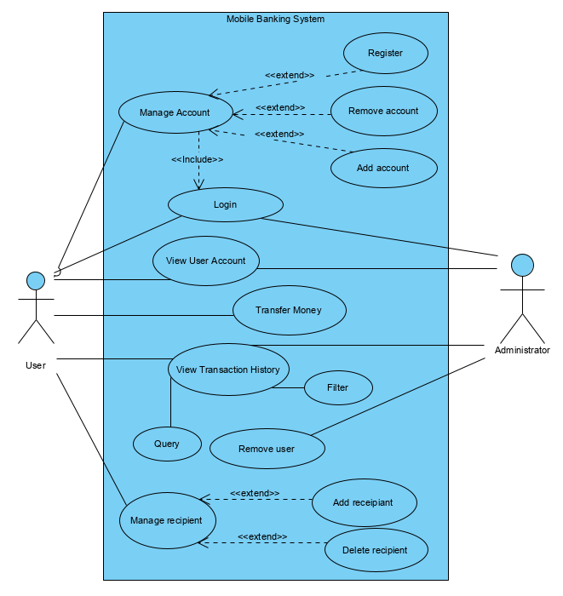

**2.0 Use Case Diagram**

1

Use case name: Login

Summary: This is the action of the user or Administrator using their application credentials to log into the application on their device.

Actors: User, Administrator

Pre-Conditions: Application must be installed; Account must have been created prior and have an internet connection

Main Sequence: Step 1.1 View login page

Step 1.2 Enter user code and password

Step 1.3 Select login

Step 1.4 Wait for response

Step 1.5 View Home Page

Non-Functional requirements: The system needs to accurate and reliable to ensure request is sent

Post-Condition: User has access to their account and bank information with in the app to be able to transfer money

Outstanding questions:

2

Use case name: Manage Account

Summary: This is the action is done by the user to ether create a new user account bank account link or to remove a bank account link.

Actors: User

Pre-Conditions: Application must be installed; Account must have been created prior and have an internet connection

Main Sequence: Step1.1 Load application manager page

Step 1.2 Select Option from Menu

Extensions: Step 2.1 Select Register

Step 2.2 Enter new Account information

Step 2.3 Select create new User Account

Step 2.4 Login

Step 3.1 Login

Step 3.2 Select Remove account

Step 3.3 Enter Account Password

Step 3.4 Confirm account deletion

Step 4.1 Login

Step 4.2 Select Add account

Step 4.3 Enter new Account Information

Step 4.4 Confirm account creation

Non-Functional requirements: The system needs to accurate and reliable to ensure account creation and deletion request is sent

Post-Condition: User has settled issue related to banking accounts linked to the application or user accounts

Outstanding questions:

3

Use case name: View User Account

Summary: This is an action which can be done by the user or administrator to be able to see their account or a specified account

Actors: User, Administrator

Pre-Conditions: Application must be installed; Account must have been created prior and have an internet connection

Main Sequence: Step 1.1 View login page

Step 1.2 Enter user code and password

Step 1.3 Select View Your Accounts

Alternative Sequence: Step 2.1 View login page

Step 2.2 Enter administrator user code and password

Step 2.3 Select view User Account

Step 2.4 Enter subject’s user code

Step 2.5 Enter Staff number

Step 2.6 Confirm account view request

Non-Functional requirements:

Post-Condition: User, Administrator has access to their account and bank information with in the app

Outstanding questions:

4

Use case name: Transfer Money

Summary: The user is able to transfer money from their account that is linked to the application

Actors: User, Administrator

Pre-Conditions: Must be logged into application; Account must have the correct amount of money to allow for the transaction to take place

Main Sequence: Step 1.1 View login page

Step 1.1 Select Transfer Money page

Step 1.2 Enter Recipient code or scan code

Step 1.3 Enter Transfer amount

Step 1.4 Confirm Transfer of money

Non-Functional requirements: The system needs to accurate and reliable to ensure request is sent

Post-Condition: User has sent money from their account to recipient user account balance has been deducted

Outstanding questions:

5

Use case name: Manage Recipients

Summary: The user is able to save and delete Recipients, who can then be called again when transferring money

Actors: User, Administrator

Pre-Conditions Must be logged into application

Main Sequence: Step 1.1 Users select Manage recipient’s menu

Step 1.2 Select Option from Menu

Extensions: Step 2.1 Select add recipient

Step 2.2 Enter Recipient code or scan code

Step 2.3 Save as recipient

Step 3.1 Select delete recipient

Step 3.2 Enter Recipient code

Step 3.3 Confirm deletion of recipient

Non-Functional requirements: This task should be updated within the database within 10 milli seconds

Post-Condition: User has ether added or deleted a recipient

Outstanding questions:

6

Use case name: Remove Account

Summary: The Administrator is able to delete a specified user account

Actors: Administrator

Pre-Conditions: Administrator must be using admin credential

Main Sequence: Step 1.1 Selects Manage Users

Step 1.2 Selects remove User

Step 1.3 Enters User Code

Step 1.4 Enter Staff number

Step 1.5 Confirm deletion

Non-Functional requirements: This task should be updated within the database within 5 milli seconds

Post-Condition: User account has been removed

Outstanding questions:

7

Use case name: View Transaction History

Summary: The User, Administrator are able to see the previous transaction the user has made with the application

Actors: User, Administrator

Pre-Conditions: Must be logged into application

Main Sequence: Step 1.1 Selects Transaction History

Step 1.2 Enter User code

Step 1.3 View Transaction History

Extensions: Step 2.1 Select Filter

Step 2.2 Confirm application of filter to results

Step 2.3 View results

Non-Functional requirements: The System Should retrieve records of a month old with in 10 milli-seconds and older records with in 2 seconds

Post-Condition: History retrieved

Outstanding questions

## STATE DIAGRAM

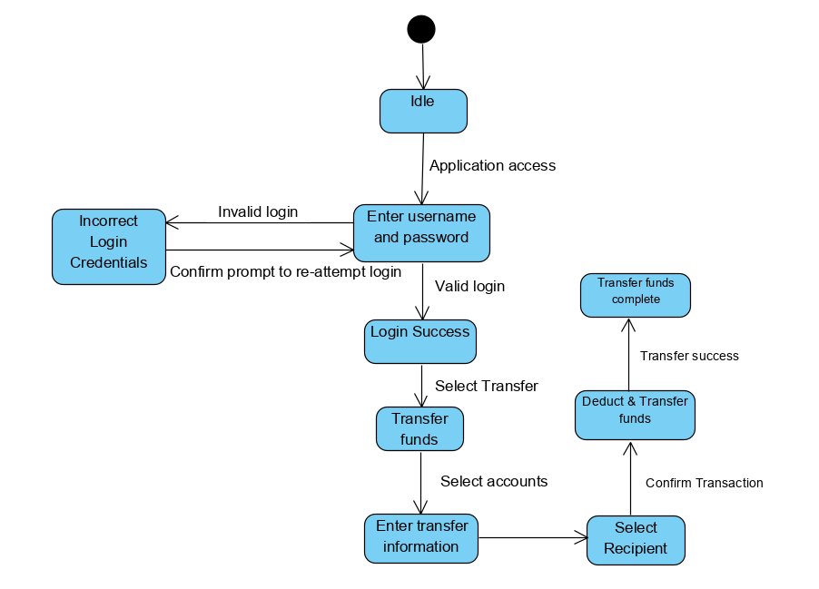

**3.0 State Diagram**

The diagram above is a state diagram which describes the different states that the application goes through as a user transfers money. At Application start-up the app is in an idle state until the login menu is displayed awaiting user input, their username and password. When the login information is verified, the system will display a successful login prompt (welcome prompt). The user then selects the transfer option. Once selected, the user enters the necessary information to process the transfer. The user then selects and enters the recipient’s information. Once processed and confirmed, the application will deduct the amount from the user’s account and add it to the recipients account which is the final stage before the application displays that the transaction has been completed.

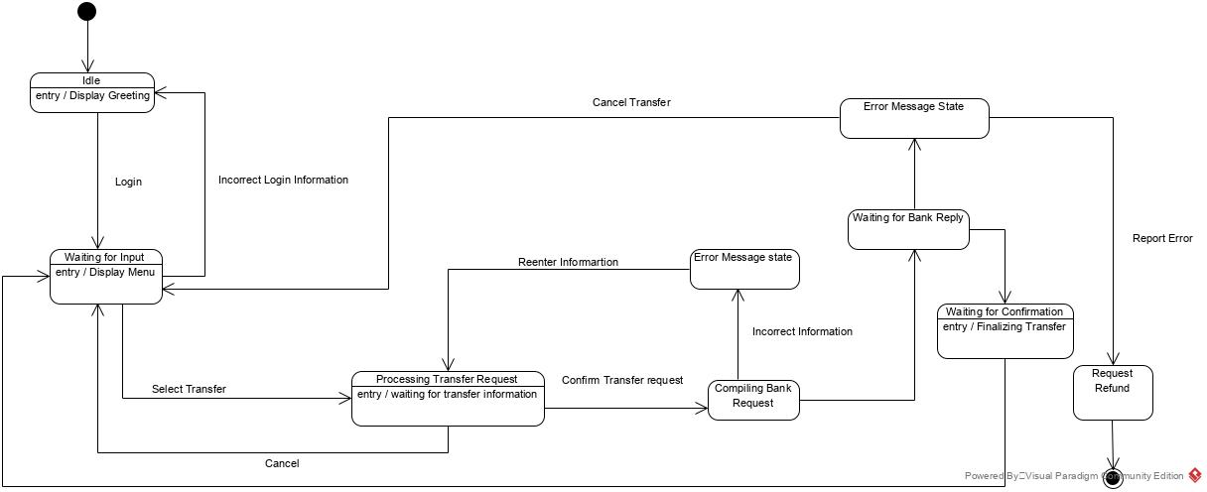

**3.1 State Diagram**

The above diagram, State Diagram 3.1 depicts the different states required to view transaction history. From the idle state, the user initiates the access of the login state where the application awaits entry of credentials. Once verified, the application will display the home page, from which the user can select transaction history. The user can either decide to view the history or the user can choose to filter the desired results. By selecting and applying a filter, the user will either view a blank page/error state where the data history does not meet the filter requirements or shown the requested filtered results.

## SEQUENCE DIAGRAM

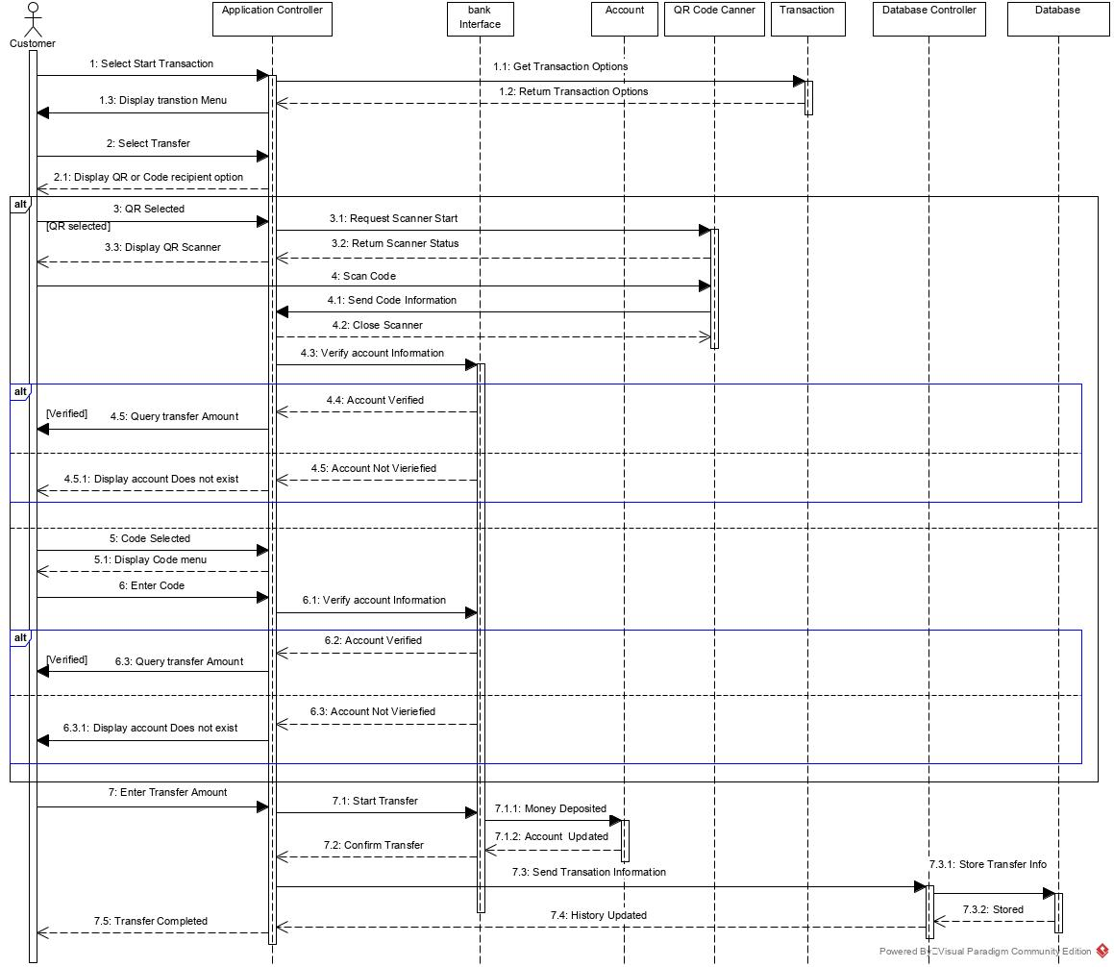

**4.0 Sequence Diagram**

Sequence Diagram 4.0 described is the transfer sequence. The diagram above describes the nesceary steps of a successful tranfer money from one account to another. When the user selects the transaction option, these are retrieved and displayed to the user. Subsequently, the user selects transfer where the user will be met with two options, entering of a code or scanning of a device using QR code implementation. If QR code is selected, the program must first start the QR code scanner and wait for a code scanned utilizing the device’s camera. Once scanned, the system will send the information to be verified before either returning account verified and querying the amount the user would like to transfer or it would display an error message to the user, alerting of an invalid request. If code is selected, the user is provided with a menu to enter the code and recipient’s data of the beneficiary they would like the funds transfered money. Once the code is entered and verified the application queries the amount requested by the user. Afterwards, once the amount has been entered and the transaction confirmed, the system will deposit the money, wait for confirmation that the money has been received, then update transaction history and display transaction complete

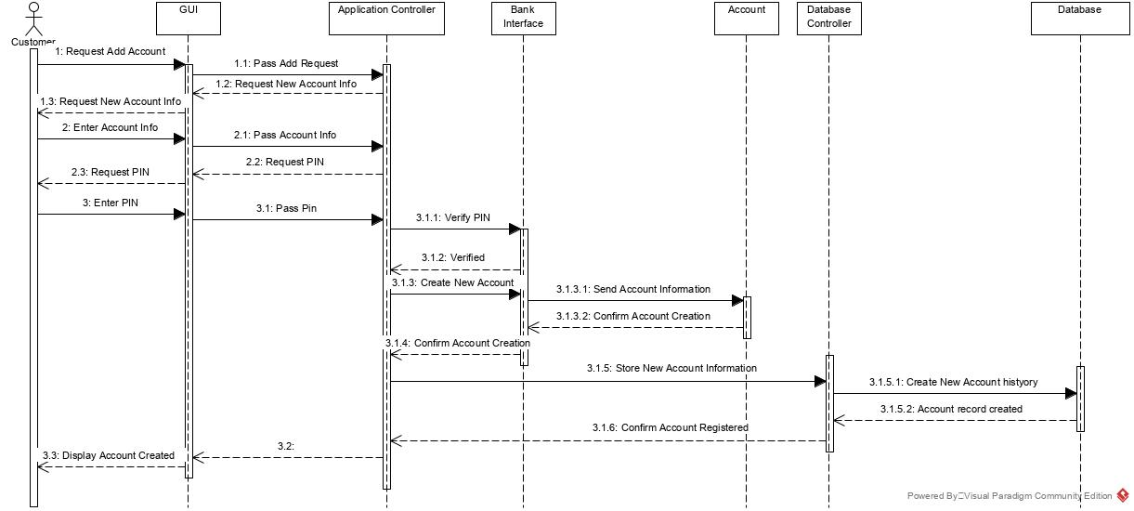

**4.1 Sequence Diagram**

The second sequence describes the events that must take place for the user to add another banking account to the application service to be managed through the application on the system.

To be able to add an account, the user must first select the “Accounts” menu and request to have another account added. The application will then request the account information for the account. After the user has entered the information, the application will then ask for the user to enter the pin for the account, which is then verified. Once verified, the information of the account from the bank can now be added to the application the structure provided by the account class. The system will then send these settings to the Database Controller to be able to store them in the database as to be called on once again and to for reference purposes of transaction history for the account.

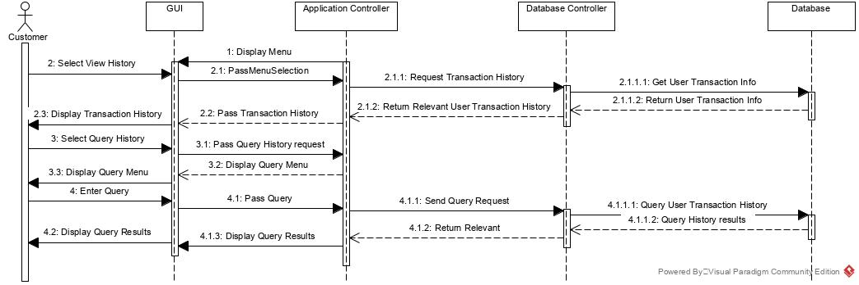

**4.2 Sequence Diagram**

The sequence diagram above describes the sequence of events that take place when a user queries their transaction history. To be able to query transaction history, the user first selects the view history option from the menu which prompts the application manager to request the transaction history from the Database Controller that retrieves data from the Database. After the information has been retrieved from the database, the Application Controller will then display the results to the user. The user will then enter their query desired, into the menu displayed with the results. The Application Controller will then send the request to the Database Controller which retrieves the query results from the database and returns it to the user for viewing.

## COMMUNICATION DIAGRAM

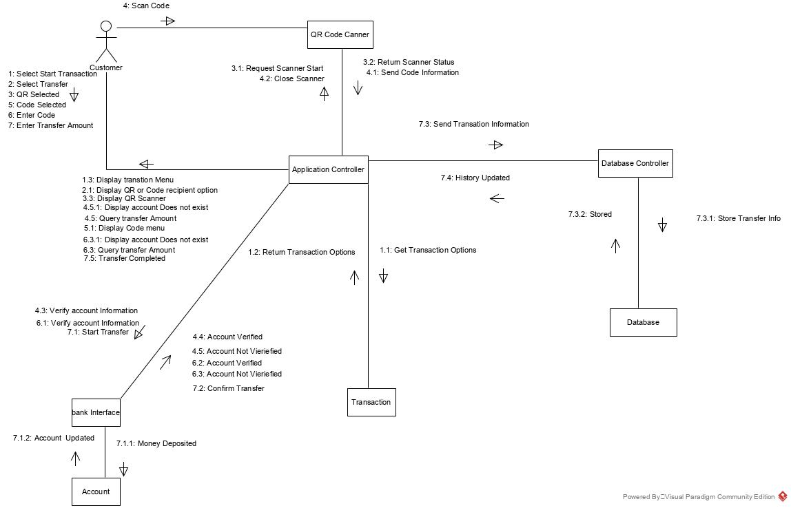

**5.0 Communication Diagram**

The communication diagram is a partner diagram to the Sequence diagram from the transfer of money to another user which shows the different messages which must be sent between the different components of the system. For the transfer of money, the different components that must be communicated with in order to send money would be the user themselves, QR code scanner, Application Controller bank, transaction class, Database Controller and the database.

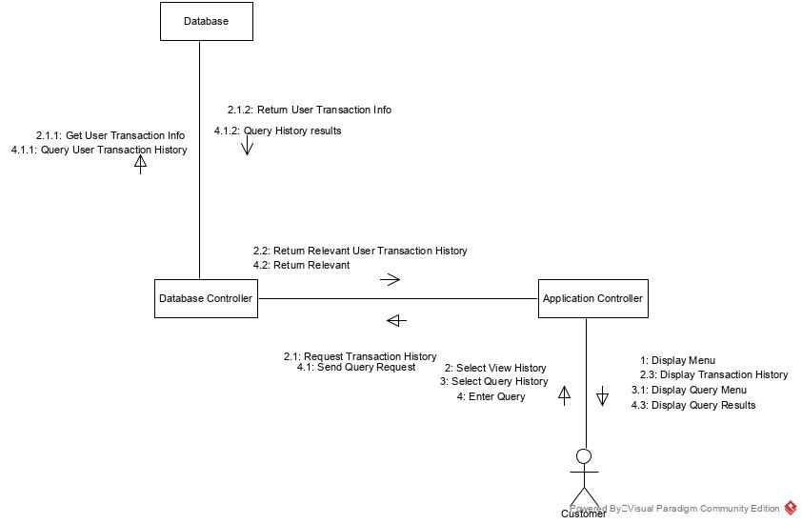

**5.1 Communication Diagram**

The communication diagram above shows the different messages which must be exchanged in order for a user to be able to view transaction history and its required communication targets.

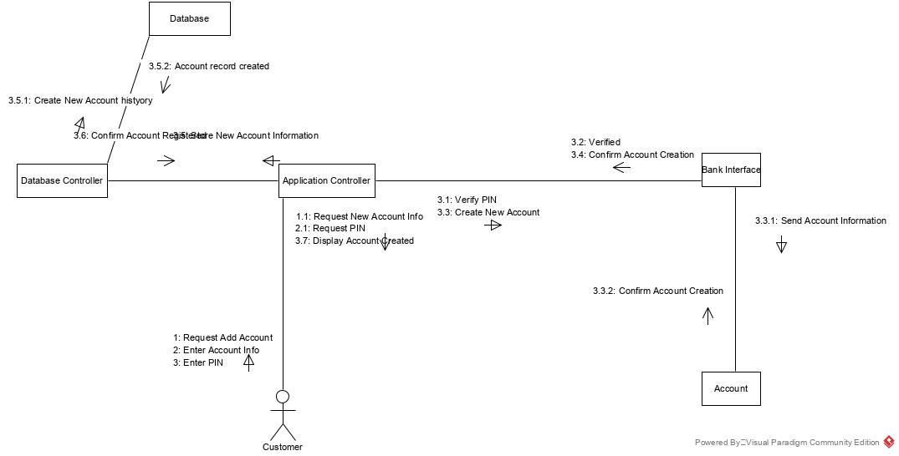

**5.2 Communication Diagram**

The final communication diagram shows the nodes and different communication that must go on with in the system to be able to allow for a user to create a new banking account in the system.

## COMPONENT DIAGRAM

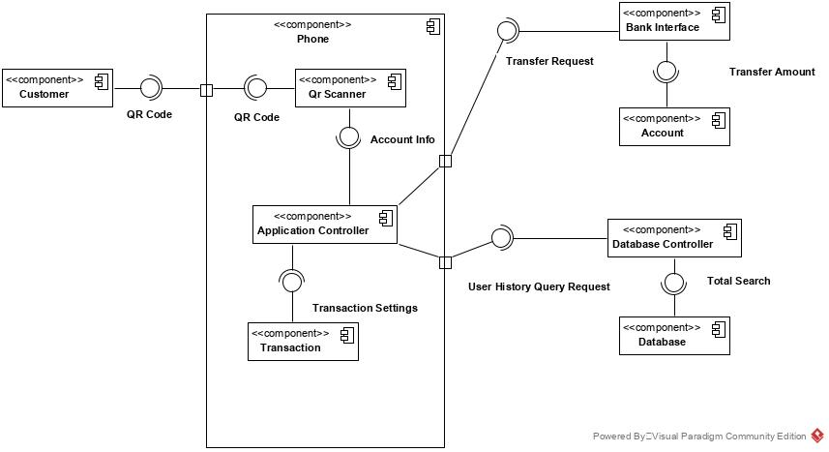**6.0 Component Diagram**

Component diagrams show the physical components of a system and the respective components that make up the system.

The above component diagram shows the different components and interface necessary for the transfer process via QR code. QR scanner uses an interface which would allow for the use of scanning using QR codes. This allows for the QR scanner to get the information from the QR code which can then be sent to the Application Controller where it is then made available for the bank to accept as a transfer request with the transfer amount to make it an actionable request.

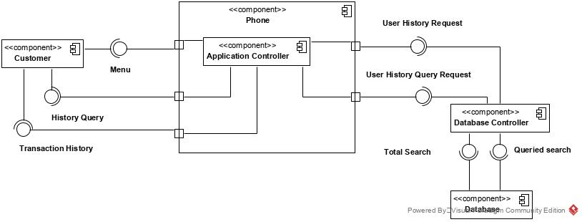

**6.1 Component Diagram**

Component Diagram 6.2 shows the components necessary for the user to be able to view their transaction history as well as query and display the transaction history. The Customer would use the menu which is provided by the application manager to be able to select the transaction history. To do this, the Application Controller would issue a transaction history request for the Database Controller to use which would the allow for the Database Controller to request information from the database then allowing for the Application Controller to display transaction history.

The user could also provide a history query for the Application Controller which utilizes the Database Controller as a user history query request that queries the database to then provide the results to the user as “transaction history”.

## DEPLOYMENT DIAGRAM

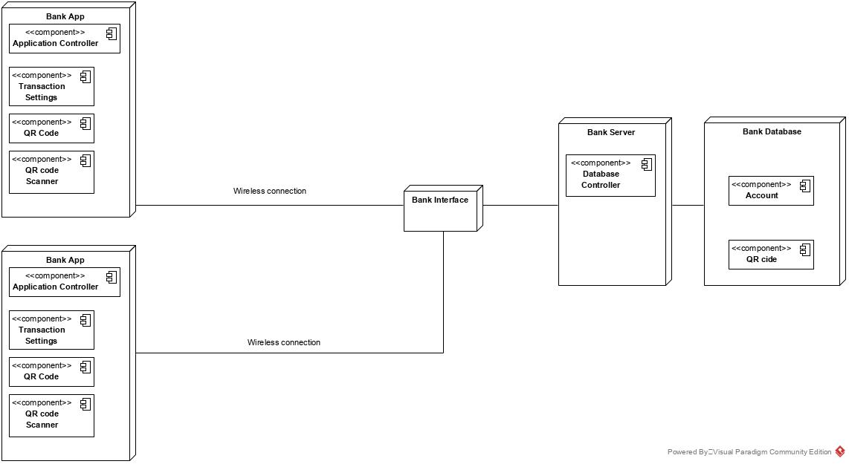

**7.0 Deployment Diagram**

This diagram is used to show the different physical components that will be used for the system to be able to perform its necessary tasks as well as the software components that will need to be on these physical attributes.

The bulk of the bank’s application system will be the user’s phone. This will then connect to the internet via a router to allow for the system to be able to communicate with that banks bank service which has been denoted as bank interface. This will then be connected to the bank server which oversees the Database Controller. The database is responsible for holding the records of its customers.